Муниципальное образовательное учреждение средняя общеобразовательная школа № 3 р.п. Земетчино

«Animals in our life»
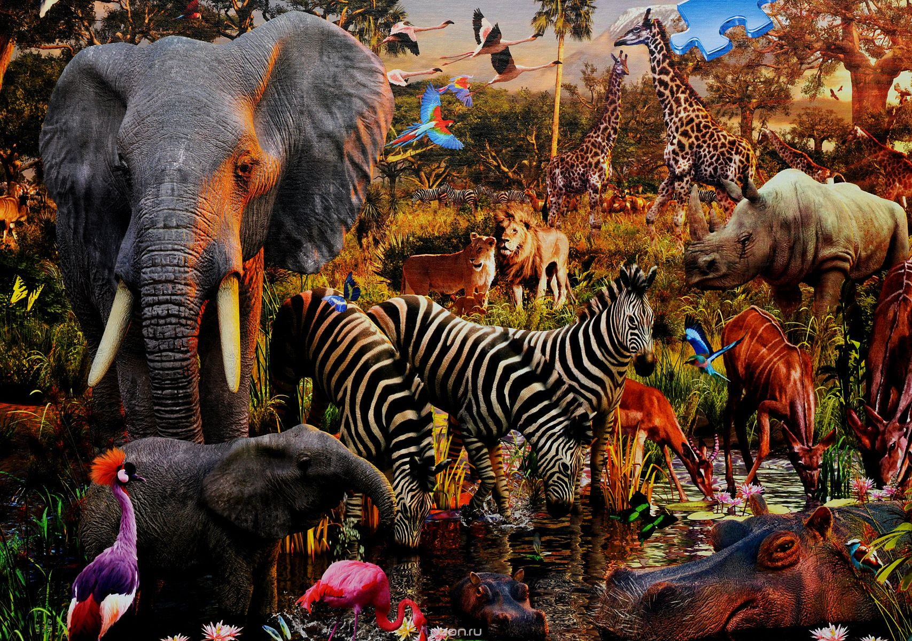

Выполнил:
Учитель МОУСОШ №3
р.п. Земетчино
Жаркова Л.А.

р.п. Земетчино
2017 год
Заключительный урок английского языка в VI классе по теме «Animals in our life»
Я провела в VI классе итоговый урок по теме «Animals in our life». Занятие было организовано в форме экскурсии в «зоопарк». Шестиклассники собрали много игрушек, рисунков различных животных, птиц. Все это помогло оформить кабинет английского языка.
Гостями на уроке были учителя английского языка нашей школы и других школ, родители.
Привожу сценарий урока, включив в него весь языковой материал.

Ведущая: Dear children, I know you love birds and animals. You take care of them. I am sure you will be glad to see different animals and birds in the zoo. Let's go to the zoo. I think it will be interesting. But before we go, listen a rhyme «To the Zoo».
Девочка читает стихотворение.
To the Zoo
We are off to the Zoo!
We are off to the Zoo!
We haven’t moment to spare.
We were going to see the kangaroo.
And feed the big brown bear.

Ведущая: Сhildren, lets sing together a very good song «Going to the Zoo».
GOINGT TO THE ZOO
Going to the zoo. Going to the zoo!
The sun is bright, the sky is blue;
Sport ty? You may come a long too.
Going to the zoo, going to the zoo!

Ведущая: : Now we are in the zoo.
Школьники рассматривают картинки, рисунки, игрушки. Ведущая предлагает детям поделиться своими впечатлениями.
Pupil: Oh, I see the zoo. What a me zoo it is! I can see a lot of animals. I can see a fox, a wolf, a monkey, a bear, a lion, a elephant, a tiger and a kangaroo. There are a lot of children at the zoo. They are looking at the monkeys. The monkeys are walking and jumping. I can see a wolf. He is eating. How nice they are! I like animals very much.
Ведущая: What animals can you see at the zoo?
Ребята по очереди отвечают: « I can see a bear and a camel», « I can see wolves, monkeys» и т. д.
Затем по просьбе ведущей дети читают наизусть стихи о животных.
A Rabbit
I had a penny,
A bright new penny,
I took my penny
To the market square.
I wanted a rabbit,
A little brown rabbit,
And I looked for a rabbit
'Most everywhere.

Our Cat Has a Flat
Our pussy-cat
Has a good, small flat.
It has no door
But a brown floor.
The walls are white
And the flat is bright.
Can you?
Can you hop like a rabbit?
Can you jump like a frog?
Can you walk like a duck?
Can you run like a dog?
Can you fly like a bird?
Can you swim like a fish?
And be still like a good child,
As still as you wish?
A Funny Little Cat
-Where are you going, my little cat?
- I am going to the shop to buy a hat.
How funny is a pussy-cat
Who goes to the shop to buy a hat!
The Bird-House
Little bird, little bird,
Look at me!
I have a bird-house,
Oh, come and see!
Little boy, little boy,
Under the tree,
I like this house,
Give it to me.

Ведущая предлагает ученице спеть разученную ею песенку «Once i Saw a Little Bird"

Once i Saw a Little Bird
Once I saw a little bird
Go hop, hop, hop;
So I said, « little bird, Will you Stop, stop, stop?»
And was going to the window
To say, «How do you do?»
But he shook his little tail
And away he flew.

Была подготовлена и показана зрителям пьеска «three Little Pigs».
Двое учащихся, выучив стихотворение читают его в форме диалога.

« Little Cat,
Little Cat,
As you sat on the mat
Did you dream
Pf a mouse,
Or a grey rat?”
“ Oh, no!
Not so!
For I always dream
Of a dish
Full of fish
And a bowl
Full of cream.»

Учащиеся хором спели английские песенки

The Bear Went Over The Mountain

The bear went over the mountain

The bear went over the
Was the other side of the mountain,
The other side of the mountain,
The bearc went over the mountain,
To mountain,
The other side of the mountain,
Was see what he could see!
And all that he could see, all that he could see.

BINGO
The farmers dog is in the yard,
In the yeard, In the yeard.
The farmers dog is in the yard,
And Bingo is his name.
Bingo, and Bingo and Bingo is his name.

Ведущая: My dear friends, you know that all domestic and wild animals and birds have babies. Listen to the verses about them.
Дети по очереди читают стихи.

Teddy-Bear

Teddy-Bear, Teddy-Bear,
Look around.
Teddy-Bear, Teddy-Bear,
Touch the ground.
Teddy-Bear, Teddy-Bear,
Switch off the light.
Teddy-Bear, Teddy-Bear,
Say good night.

Babies

The hen has a chicken,
What does it say?
Cheep, cheep, cheep, cheep!
All through the day.
The duck has a duckling,
What does it say?
Quack, quack, quack, quack!
All through the day.
The sheep has a lambkin,
What does it say?
Baa, baa, baa, baa!
All through the day.
The pig has a piglet,
What does it say?
Squeal, squeal, squeal, squeal!
All through the day.
The cat has a kitten,
What does it say?
Mew, mew, mew, mew!
All through the day.
The dog has a puppy,
What does it say?
Bow, wow, bow, wow!
All through the day.
The snail has a baby,
What does it say?
It doesn`t say anything
All through the day.

Ведущая: «What do we call…»

a baby- dog?
a baby- pig?
a baby- cow?
a baby- horse?
a baby- cat?
a baby- bear?
a baby- goat?
a baby- swan?
a baby- sheep?
a baby- duck?
a baby- hen?
a baby- mouse?
a baby- wolf?
a baby- hamster?

Учащиеся отвечают: a puppy, a piglet, a calf , a colt, a kitten, a teddy- bear, a kid, a cygnet, a lamb, a duckling, a chicken, a mouse, a wolf-cub…
Вывешиваю таблицу со словами. Дети называют животных и его детеныша.

a puppy a cat
a piglet a cow
a calf a pig
a colt a bear
a kitten a horse
a teddy- bear a goat
a kid a dog
a cygnet a sheep
a lamb a mouse
a duckling a wolf
a chicken a swan
a mouse a duck
a wolf-cub a hen

Ведущая: Children, you know that many people have pets. Please, tell us stories about your own pets.

Учащиеся рассказывают о своих любимцах. Например:

«I have a goat. It lives in the shed. It is white. It gives us milk. We like the goat very much. We have a nanny-goat and a billy-goat too. Our nanny-goat is grey and our billy-goat is brown. They have a kid. Its very nice. It runs and jumps in the yard. It is my pet. In like to play with it.»

Далее, в программе принимают участие пять учеников. По очереди они прикрепляют к магнитной доске заранее приготовленные рисунки передних ног разных животных, и каждый учащийся коротко рассказывает о своем животном, не называя его. Ребятам предлагается угадать, что это за животное, и назвать его.

These feet belong to a big animal. This animal can draw a cart. This animal helps the farmer. Whoso feet are these?

These feet belong to a big animal. This animal gives milk. Each foot has two toes. Whose feet are they?

These feet belong to a very big animal. You can see this animal at the zoo. This animal has a trunk. Whose feet are these?

These feet belong to an animal that barks. This animal sometimes guards the house. This animal sometimes helps the hunter. Whose feet are these?

These feet belong to a small animal. This animal catches mice. This animal likes to wash itself with its paws. Whose feet are these?

Ведущая: Well, girls and boys. It’s very good that you know so much about animals, that you have pets at home and that you take care of them. But you must remember that animals and birds are our friends.

